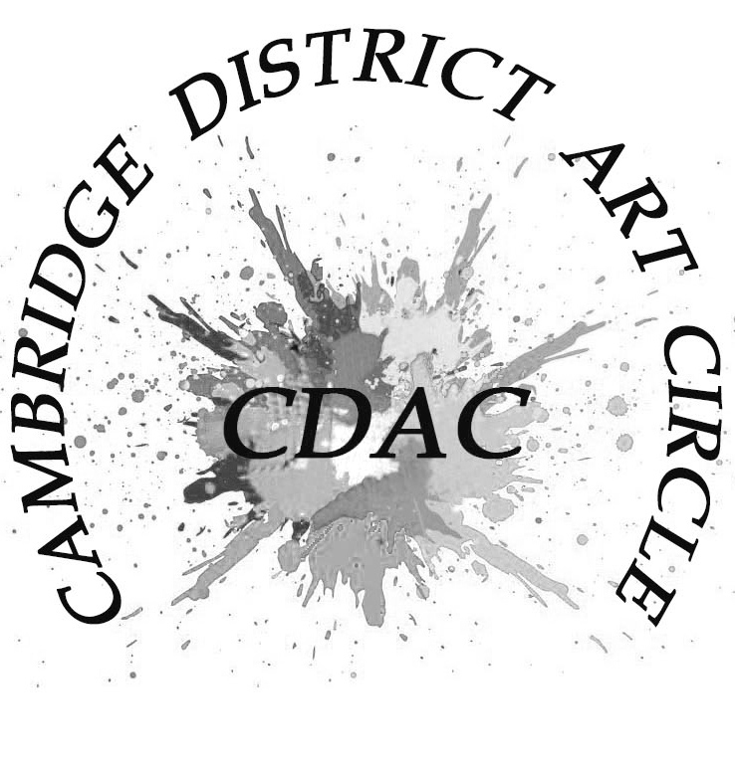

Membership 2025/26

Please complete and return electronically to the Membership Secretary ([lesleyrumble@macace.net](mailto:lesleyrumble@macace.net)) or print out and hand in at the next meeting.

Name ………………………………………………………………………………………

Address ……………………………………………………………………………………

………………………………………………………………………………………………

………………………………………………………………………………………………

Post Code …………………………...........................................................................

Telephone No. …………………………………..........................................................

Email address ……………………………………………………………………………

What Medium do you paint in?

………………………………………………………………………………………………

What would be your interests in joining the Art Circle?

1. Attending Meetings / demonstrations yes/no

2) Attending Workshops yes/no

3) Entering Exhibitions yes/no

4) Taking part in painting days yes/no

5) Serving on the Committee or helping at events yes/no

6) May we put your email on the CDAC website yes/no

7) May we send you attached forms etc by email yes/no

Do you belong to any other Art Societies?

……………………………………………………………………………………………