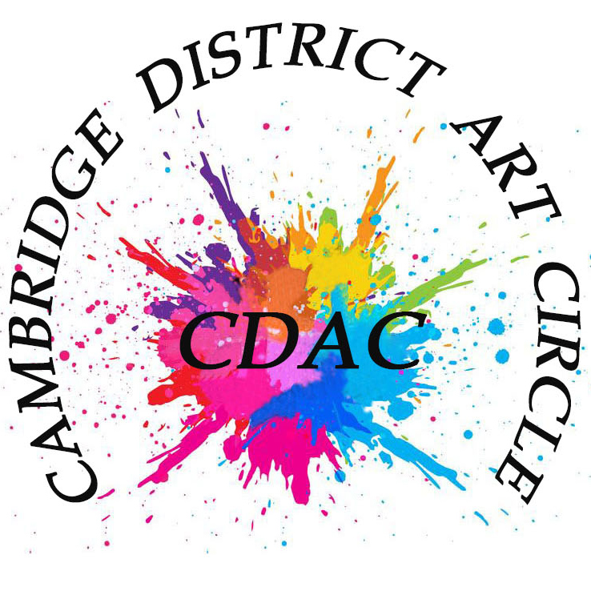

Subscriptions of £35 are due now for 2025/26. Payment may be made electronically, by cash, card, or by cheque.

Electronic payment is preferable.

**Electronic payments, quoting your name as the reference, should be made to:**

**Cambridge District Art Circle: Lloyds Bank Sort Code 30 91 74 Account number 02175743**

Cheque payments. Cheques payable to Cambridge District Art Circle can be posted to

George Meliniotis,

14a Rose Lane, Melbourn, Nr Royston, SG8 6AD

Please enclose the subscription form below

Subscription Return Form. Please return with cheque for £35 to the treasurer

George Meliniotis, 14a Rose Lane, Melbourn, Nr Royston, SG8 6AD

Name…………………………………………………………………………………………..

Address…………………………………………………………………………………………..

…………………………………………………………………………………………………….

Email………………………………………………………………………………………………..

Telephone number…………………………………………………………………………………

Please also inform Membership Secretary Lesley Rumble of your payment.

lesleyrumble@macace.net