



**School Newsletter**

October 2019

**Dear Parents**

***I hope you all had a wonderful holiday.***

***We are now well into Autumn, a season that offers***

***harvest and colour before we settle into Winter.***

***An important reminder for all children to wear warm jackets and coats to enjoy playtimes at this time of year.***

***As someone once said, there is no bad weather in Scotland just poor choices in clothing☺***

**Keeping safe!**

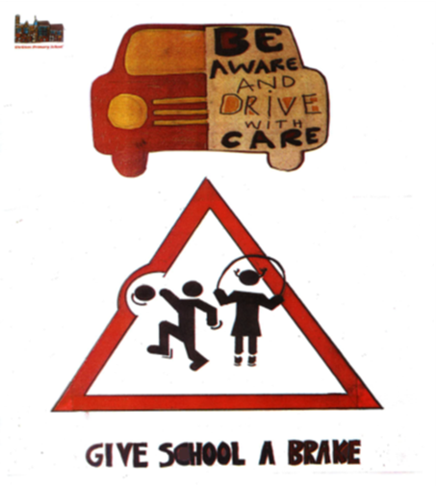

We have for some time now been aware of the increased volume of traffic around our school at ‘drop off’ & ‘pick up’ time. The traffic at these times continues to cause us concern for the safety of your children, with the speed and parking of cars a particular concern. All children ask that you continue to be thoughtful, considerate and mindful of how you drive and where you park your car on these dark Autumn days. Why not leave home that wee bit earlier and park near the village green and walk the last bit of your journey ☺

**DIRLETON CENTENARY RAINBOW ORCHARD FESTIVAL**

Our annual orchard festival took place prior to the October holiday and once again was a resounding success. The weather, whilst threatening, was favourable and a great morning was had by all. Thank you to those parents who supported the school in organising this wonderful event. Lots of exciting learning took place and lots of fun was had.

The juicing taster session was very interesting with your children voting the orange zinger the tastiest juice. Other flavours that were tasted included the Minty Refresher, Dreamy Detox, Amazing Apple and the Ginger Zinger. We were so impressed with these healthy juices that some of our senior children will be attempting to re-create these for a possible trialling at our school tuck shop as we aim to be more sustainable and self-sufficient.

**Wrapper less Snacks**

When considering what to provide for a playtime snack we ask all children & families to consider providing wrapper less snacks; snacks with less/no packaging, snacks provided in reusable containers. We are keen to reduce our waste and lessen the possibility of litter in our playground, promoting wrapper less snacks will support us in addressing these issues. For parents of our younger children, **PLEASE REMEMBER** - All children in P1/2 are offered free fruit each day so an additional playtime snack for our infants is really not necessary and the lack of one may indeed encourage our younger children to take more fruit or indeed try familiar and unfamiliar fruits. As we consider our status as an environmentally friendly school, encouraging all children to bring a snack with less packaging is something we ask you to support and encourage, **watch this space for more info…**

**Parental Consultations**

As usual, there was a great turnout of families attending the parental consultations. It was pleasing to note that almost all children participated in this important conversation. Children are encouraged to be partners in their learning whilst at school so being involved in this three way dialogue encourages them to reflect on their progress and to consider their next steps. You should have received targets that your children are working toward achieving at this meeting, allowing you to support your children’s learning out with school

**Book Week Scotland > 18th – 24th November**

During Book Week Scotland we will be offering some of the older books from our library to children & families; donations for these books will be happily received, any funds raised will go to buying new books for our library. These books will be displayed each day during book week and after assembly on Friday 24th November.

**School Photos**

Individual and sibling school photographs are scheduled to be taken on Monday 25th November. The local photographer, Emma Martin has taken these photos over the last couple of years but this year these photos will be taken by the company Tempest who had taken them previously. Tempest are providing the school with their local manager to take these photos. I’m sure these photos will be excellent stocking fillers and will help put smiles on faces.

Class photographs will be taken later in the school year by Tempest also, this date is still to be confirmed.

**Supporting Charities**

AS mentioned in the last newsletter, our school we will be supporting 4 charities this year, as decided by our school community.

The 4 charities that we will support this year are

* **East Lothian Food Bank**
* **Edinburgh Children’s Hospital Charity**
* **Chest, Heart & Stroke Scotland**
* **The Make a Wish Foundation**

The first fundraiser associated with these charities will take place on Friday 8th November when we invite everybody to come to school with **‘CRAZY HAIR’. Affordable donations will be welcomed and all funds raised will go to Edinburgh Children’s Hospital Charity.**

**We are still happy for Children to come dressed in ‘Spotacular’ fashion for Children in Need on Friday 15th November but please note we will not be fundraising at school on this day.**

**SAVE THE DATE – Fri 13th Dec**

Our Christmas Fair will take place on Friday 13th Dec.

It will follow a similar pattern to last year, with the NBHS Brass Band kicking things off by bringing their festive joy to our school and playing songs from the season; The Brass Band are scheduled to join us shortly after 11am. Our Fair will open to adults after the Brass Band have finished and will continue into the afternoon when school finishes. A few things are still being finalised but there will be lots of festive favourites on offer, with opportunities to purchase Christmas gifts, warming foods and word on the street is that Santa may even make an appearance. Please join us for this fabulous day when our community comes together and looks forward to Christmas. **More info to follow…**

**P1 Enrolment for Session 2020/21**

**Children who will be 5 on or before 28 February 2020 can be enrolled to start school in August 2020.**

**The enrolment of primary one pupils who should start school in August 2020 will take place at Dirleton Primary School on the mornings (9.30am to 12.00 noon) of 4th & 5th November 2019**

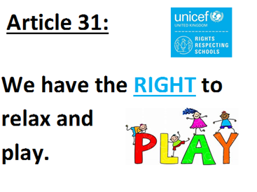

As we now head towards Christmas and all that that brings, I wanted to praise our children for the great start to this school year and make a special mention of their increasing responsibility in their approach to play. You will be aware that we have made many changes to our school playground over the last few years and have been promoting a greater emphasis on kindness, friendliness, managing risk, taking responsibility for personal behaviours and developing your children’s resilience in relation to play. The introduction of our playpod and the changing nature of what is in our playground has assisted us in supporting your children to develop in these areas and I have been happy to note happy, busy, imaginative play at the start of this school year. I hope that this good start continues as a happy playground really does help to improve all aspects of school life for young children

***AND A GENTLE REMINDER***

***SUPPORTING CHILDREN WITH ALLERGIES***

**The school would like to remind all children & families that we are now ‘A NUT FREE SCHOOL’.**

**We seek the support of all by asking that our school is a ‘NUT FREE SCHOOL’ to support those children with allergies that at times can be life threatening.**

**We ask that all children and families do their best to avoid any nuts coming in to school at any time.**

**Thank you in advance of your continued support with this**

**B. Moody**

**Head Teacher**

***Dates for your diary***

**November:**

**Monday 4th P1 Enrolment for Aug 2020 starts 0900-1200**

**Tuesday 5th P1 Enrolment for Aug 2020 starts 0900-1200**

**Friday 8th Fundraiser Crazy Hair Day for Edinburgh Children’s Hospital**

**Charity**

**Monday 25th School Photographs Individual and Family**

**December:**

**Thursday 5th P7 STEM (Science Technology Engineering Maths) trip to**

**Edinburgh College (details to follow)**

**Tuesday 10th Christmas Lunch in School**

**Thursday 12th Pantomime at Brunton Theatre (details to follow)**

**Friday 13th Christmas Fair**

**Friday 20th School Holidays begin**

**January:**

**Tuesday 7th In service Day**

**Wednesday 8th Pupils return to School**