DIRLETON VILLAGE VOICES VILLAGE CHOICES
From the Village
For the Village
Chosen by the Village

Voting Paper
We hope that you will be able to attend our Voting Afternoon on the 23rd November between 1-4pm
(Voting 1 – 3pm) in the Kirk Hall to chat to those who have made a bid for funds.
But if you are unable to attend please complete this Voting Sheet between 11th – 19th November and return it to one of the Boxes located at the Amalfi Cafe & Castle Inn.

You can vote for FIVE of the NINE projects below.
Total Village Voices Fund Available: £3125 Total Value of Bids: £4720
Put a X in the five boxes you wish to vote for
Projects |  | X
1.Andrea Mannion: Senior Mo(ve)ments. Dance Fitness Classes for Seniors.
To fund weekly cost of Kirk Hall during 2020.
2.Dirleton Book Club: The Book Nook: Phone Box Book Exchange & History Trail

3.Dirleton Bowling Club: Smaller Bowls for Smaller Hands – for Lady and Child beginners

4. Dirleton Crafters: Provide ‘Bank’ of Materials & Tools, Provide Master Classes

5. Dirleton Jogging Group: Jog Leader Training and event promotion

6.Dirleton Kirk: ‘Screen on the Green’ – Roll-up screen for Kirk Hall use by Groups

7. Dirleton Playgroup: Embracing ICT is Fun! Cameras & CD Player for Children

8. Dirleton Primary School: The Herb Hub - a Herb Garden to share with Community

9 Grace Turnbull: Ease into Pilates to improve flexibility and balance for 50+
To fund weekly cost of Kirk Hall during 2020
Name * | Postcode

Declaration | Please tick
I understand that I am only allowed to allocate my votes once

*N.B. These Voting Papers will be destroyed once the votes have been collated, verified & announced.
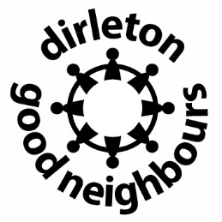 GULLANE AREA COMMUNITY COUNCIL

