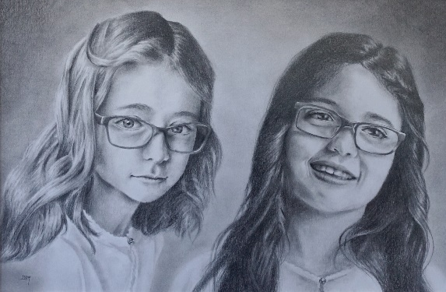
Commissions Price Guide

Portraits, Cars, Animals, Buildings, Landscapes, and other Subjects are priced according to media, size and time taken (due to complexity of subject matter/style) and any additional research, (sketches, mock-ups, photographic sessions). Below is a guide to estimated prices.

Graphite
A5 £30
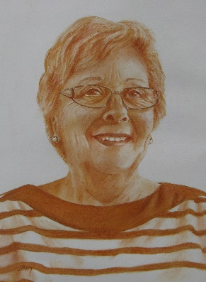
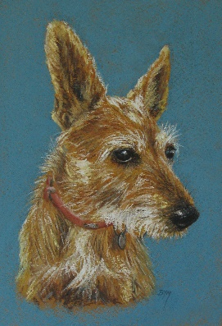
A4 £60
A3 £120
A2 £240

Sanguine or Monochrome Pastel
A5 £35
A4 £70
A3 £140
A2 £280

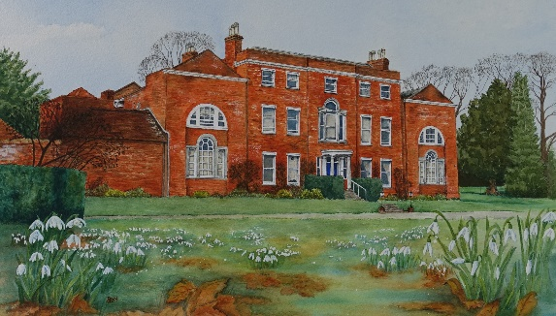
Full Colour Pastel or Coloured Pencil
A5 £40 - £60
A4 £85 - £120
A3 £160 - £240
A2 £320 - £480

Watercolour or Pen and Watercolour Wash
A5 £50 - £100
A4 £100 - £200
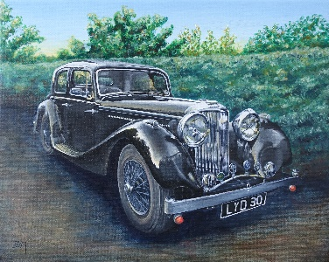
A3 £200 - £400
A2 £400 - £800

Acrylic on Canvas or Canvas Board
A5 £60 - £110
A4 £120 - £220 (E.G. 24x30cm Canvas)
A3 £240 - £440 (E.G. 30x40cm Canvas)
A2 £480 - £880 (E.G. 40x60cm Canvas)
A1 £960 - £1760

* ‘A’ sizes are given as a guide only, other sizes are available. In the case of canvases or artwork to fit certain frames the price range will be the nearest ‘A’ size to the actual canvas/frame dimensions. For instance a 24x30cm canvas will fall under the A4 price range.

Extras for portraits that include:
Each extra person/animal + £15
Any other extras are to be discussed (e.g. Props, musical instruments, complex backgrounds etc.)

Framing and Mounts
I can frame or mount artworks on paper if required. Frame/mount costs are charged separately and can be discussed to meet your personal preferences and budget. There is a charge for assembly of £10.

What you need to know about commissioning an Artwork
If you would like to commission an Artwork the information below will give you an idea of what is involved. If you have any further questions, please contact me.

Reference Photos
Good photographs are essential. In order to create the best likeness, I will need a selection of 2 - 5 clear photos. I usually work from one photo for the main pose, but I like to see a few more photos to give me a better idea of the subject’s features. When providing a range of photos it is helpful for you to point out which one shows the most likeness to the actual colours. I often recommend the subject having a 3/4 pose rather than completely face or side on.

If you decide to take photos specifically for the artwork, it is a good idea to take them outside or in a room with a lot of natural light. Avoid long shadows or shadows cast over the subject. Also, try to get down on the same level as the subject. This will mean they will be looking directly at the camera, as looking down on or up at the subject can make the subject look distorted. It's always good to see close up photos of the eyes or particular features which might get lost in a photo taken from a distance.

The photos can be digital or printed but need to be in focus, well-lit and high quality, (ideally 300dpi for digital photos). If you’re not sure if your photos are suitable, send them to me anyway and I will be able to tell you if I can use them for your portrait.

In some cases I can also visit to take my own reference photos. If you would like me to come and personally photograph the subject(s) AND live within a 10 mile radius of Basingstoke I am happy to visit for the cost of my travel and time.

Ordering
When you have chosen your photos, you can email them to me in a high resolution or alternatively you can post them to me (digital photos should be on a cd not printed as this can change the colours). If you decide to post photos, please make copies and send them via signed for or recorded delivery. All photos will be returned with the finished artwork.

The first step is to decide what type of media you want (graphite, pastel, watercolour, acrylic etc.), how large you want the artwork to be, if you want a plain or detailed background and if you would like the artwork framed or mounted. I can give you individual guidance through these questions to ensure that the artwork is just right for you.

I will email you a commission agreement stating the chosen media, size, framing or mounting details and final price. Payment of the initial deposit indicates your agreement to the commission terms. I can then start on your artwork or secure your place in my schedule. I require a 40% non-refundable deposit to cover materials and to begin the portrait.

Each portrait takes many hours to complete and can take 5 - 10 weeks depending on the choice medium and my schedule. At busy times I may need to set up a waiting list for commissions.
If there is a special date you would like the portrait for (birthday, anniversary, etc.) please let me know and I will inform you if I will be able to complete the portrait in time.

I can keep you involved in the creative process throughout with regular updates or if you prefer to wait and see a photo of the finished portrait just let me know.

When I have completed your portrait, I will email you a photo for approval. If there are any areas needing to be tweaked they can be done at this stage. Once approved I will mount/frame the artwork and you will receive the invoice for the final payment.

You will then be able to collect the artwork or I will securely package and post your portrait as soon as I have received your payment including packaging and delivery costs.

Payment
You will receive an invoice for the deposit and another for the final payment. You will be able to pay via Bank Transfer or PayPal.

Delivery
Artworks are securely packaged flat with layers of bubble wrap and posted via special delivery or currier, tracked and signed for. I make every effort to ensure your artwork arrives in perfect condition. Delivery costs are calculated separately for each artwork. You are also welcome to collect your artwork in person.

Title of Ownership, Copyright and Reproduction Rights
Title of ownership of the work shall pass from the artist to the client upon the client's full payment of the artist's fee. The artist retains copyright and reproduction rights over the work for commercial and promotional purposes. The client may not copy the artwork without written permission of the artist.
Publicity Material, Website, blog and Facebook/Instagram etc.
Most of the portraits will be added to my website, social media pages and blog, I do not name the sitter without permission and may give the portrait an alternative public title. I may also use images for other publicity purposes; on posters or as examples for future clients. If you do not wish me to use your portrait for any of the above, please let me know at the time of ordering. If it is a painting of your car I can hide or change the registration plate before putting online.

Frequently Asked Questions

I would like a portrait with more than one subject, but I don't have a photo of them together.
I can work from separate photos and put the subjects together in one portrait.

Will my portrait/pet portrait have a Background?
Portraits are given a plain colour/tone background to compliment the subject. There is an additional cost if you would like a detailed background.
Will I have a preview of my portrait before it's delivered?
I always send a preview of the finished portrait via email before final payment and delivery. You can also arrange a studio visit with me to preview in person.

I want copies of my portrait, what do I do?
All portraits I produce are my copyright and cannot be reproduced without my permission. If you require copies, you can order prints or cards by simply emailing me. You do not need to order them at the time of commissioning a portrait as I always keep a digital copy of each portrait.

What does it mean when you say ‘the artist retains Copyright and Reproduction Rights’?
Although you have purchased the painting and it is from your photograph, the portrait / pet portrait has been created by myself and only I am able to use it publically or make copies, (e.g. on my website, prints of originals, using them as an example of my work). I will respect anyone’s wishes if they do not wish their portrait / pet portrait to be shown on my website, just let me know.

Can you frame my portrait?
Yes, I can order a standard or bespoke frame in a variety of styles or use a frame you supply. I can also provide the artwork with just a mount so that you can frame it or take it to a frame shop yourself. Please let me know your framing requirements before I start the artwork. This is so that I can make the artwork to fit the size of a specific frame or if ordering a frame ensure that it arrives in time, this is particularly important for bespoke frames which take longer.

I hope this information has been helpful. I look forward to creating a special artwork for you.

A bit more on Photographing Pets
- Photographs taken outside or by a large window are the best to avoid unnatural lighting and colouring of your pet.
- Try to avoid a really sunny day as the sun will create big shadows on your pet. This in turn can make certain details hard to see. The best sort of day for taking photographs is an overcast, but bright day. People often make the mistake of thinking a sunny day is the best. As mentioned it can cause awkward shadows and cause your pet to squint if looking into the sun.
- Position yourself to avoid casting your shadow across your pet or shadows from other objects.
- Take the photographs for your pet portraits at their level. This will avoid distortion and unnatural pose. For a head and shoulder portrait I often recommend the subject having a 3/4 pose rather than completely face or side on. This is just what I think makes the best pet portraits. Of course it depends on what you are looking for.
- Try to get as close to your pet as possible. This will ensure you get more of the subject in than the background.
- Make sure you keep the image in focus as this will give the maximum amount of detail and make painting the portrait easier as I can pick out the individual markings and details that make up your pets character.
- What camera? Some phone cameras are so good now it is totally possible to produce a portrait taken from a phone photo. The same principles apply to any other camera you would use and make sure it is full resolution please. Remember it is worth taking as many photos as possible.
- Often people struggle because their subject won’t sit still. If possible take a friend with you so they can tempt them with a treat, toy or similar while you take the photo. The beauty of this digital age we can take as many photos as we need without wasting film, so it really is worth keeping at it so you get the best photo possible for your pet portrait. Make it fun for both of you and you will get that perfect photo.

