Isolation! Guided circular walk from St Peter Mancroft to St Peter Mancroft
1 hr 6 min (3.3 miles)
Start outside the Forum
1. St Peter Mancroft Walk west towards Millennium Plain
Standing at the stop of the steps, and near the handrail with your back to the Forum, look up at the church tower - how many P's can you see?
2. Turn right onto Millennium Plain
3. Turn left onto Bethel St
4. Turn left onto Cleveland Rd
5. Turn right onto Upper St Giles St
6. Arrive at location: St Giles on the Hill
Above the entrance door, what is the Saint holding in his arm?
7. Walk west on Upper St Giles St towards Cow Hill
8. Turn right onto Cow Hill
9. Arrive at location: Cow Hill
10. Walk north on Cow Hill towards Willow Ln
11. Turn left onto Pottergate
12. Turn right onto Wellington Ln
13. Arrive at location: St Benedicts Church
Looking up at the tower, how many sides does it have?
14. Walk north on Wellington Ln towards St Benedicts St
15. Turn right onto St Benedicts St
16. Turn left at Ten Bell Ln
17. Continue onto St Swithins Alley
18. Arrive at location: Saint Swithins Alley
19. Walk north-east on St Swithins Alley towards St Swithins Rd
20. Turn right onto St Swithins Rd
21. Continue onto Westwick St
22. Turn left onto Coslany St
23. Continue onto Oak St
24. Arrive at location: St Michael Coslany, Norwich
How many figures are on a door and what are they?
25. Walk north on Oak St towards Indigo Yard
26. Turn right onto St Marys Plain
27. Arrive at location: St. Mary's Church
What is the Viking round tower "a legacy of"?
28. Walk north-east on St Marys Plain towards Duke St
29. Turn right onto Duke St
30. Turn left onto Colegate
31. Arrive at location: St George's Church
What gold creature is lying above the clock?
32. Walk east along Colegate onto Magdalen St
33. Turn right onto Fye Bridge St
34. Turn left onto Fishergate
35. Walk down towards Hansard Ln
36. Arrive at location: St Edmunds Church
Standing at the end of Blackfriars Street, how many glass windows can you see?
37. Walk east up to end of Fishergate
38. Turn right onto Whitefriars
39. Walk over the bridge heading southwards
40. Turn left onto St Martin-At-Palace Plain
41. Arrive at location: Saint Martin-At-Palace Plain
Standing at the entrance gate and looking up at the tower - if it was a cake, how many tiers would it have?
42. Walk south-west to the end of Bishopsgate
43. Turn left onto Palace St
44. Continue along Palace St
45. Turn left onto Tombland
46. Walk towards Queen St and stop before the building of Haart Estate Agents, turning to your right
47. Arrive at location: St Mary the Less
What is the name on its entrance door?
48. Walk to the corner of Queen St and turn east
49. Walk to end of Queen St
50. Arrive at location: St Michael-at-Plea, Norwich
Looking up at the tower, what is the clock asking?
51. Turn around and walk to Agricultural Hall Plain
52. Cross the road and turn onto King St
53. Walk to junction of Rose Lane, cross over and continue walking along King St on your right
54. Arrive at location: St Peter Parmentergate
What are the two seated figures above the door each holding?
55. Resume walking along Kng St
56. Pass by Dragon Hall
57. Pass by The Waterfront
58. Pass by Wensum Lodge
59. Arrive at location: St Etheldredas Studios
What is the shape of the top section of its tower and what is the shape of its bottom section? And how many path lamps are there?
60. Continue walking up the churchyard path onto Rouen Rd
61. Turn right onto Rouen Rd
62. Walk full length towards city centre
63. Stop close to Cattle Market St
64. Turn left onto Golden Ball St
65. Turn right onto Timber Hill
66. Arrive at location: St John the Baptist's Church, Timberhill, Norwich
Over the entrance, what is St John wearing?
67. Walk down Timberhill to Orford St
68. Turn left onto Red Lion St,
69. Cross Red Lion St
70. Turn left at Orford Place
71. Walk to end of Orford Place
72. Turn left onto Haymarket
73. Turn right onto Hay Hill
74. Arrive at location: St Peter Mancroft
To see this route visit https://goo.gl/maps/xrLNwCNWEkEbZHGYA
For the answers to the questions visit morgan.wyche.art

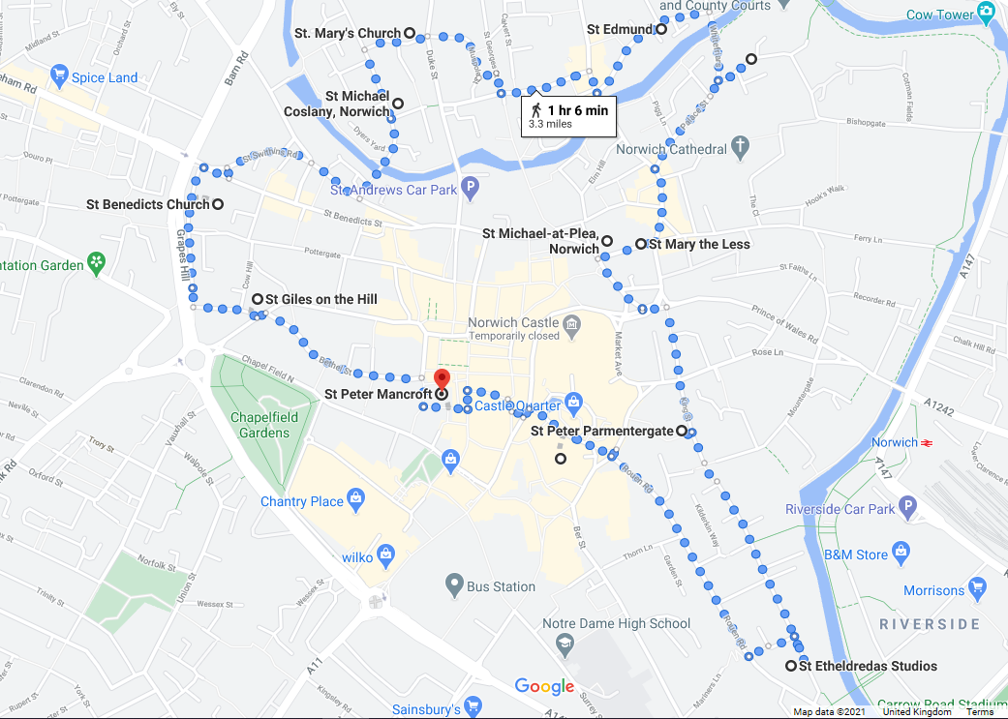

Church History

- St Edmund's Church is Grade I Listed and is medieval, dating from the 13th century. The nave was restored in the 1860s. The building suffered damage in the War, and when Cautley visited in 1946 he was unable to get inside. For years after that, the church deteriorated until it was little more than a shell. However, St Edmund is one of the few churches that appears to have benefited from the Brooke Report of the late 1960s, which resulted in large numbers of the Norwich city centre churches being declared redundant and threatened with demolition. Renewed interest in caring and finding new uses for Norwich's redundant churches, led to its repair and renovation by the Norfolk Churches Trust. Return to walk.
- St Martin-at-Palace Plain is a medieval church that was restored in the mid nineteenth century by Edward Hakewill. After being made redundant in 1971, the church became reused by the Norfolk Probation Service in 1987, because it is close to the Law Courts. This resulted in some screening being provided in two chancel chapels, to create meeting-rooms, and inserting a three-tier mezzanine floor in the north aisle. Below that excavation works, on two descending levels, provided an opportunity for archæological investigations. Other improvements included restoring the north aisle roof in 2007. MoveOn East then succeeded the Probation Service but vacated the building in 2012. It then stood empty until 2017 when the Norwich Historic Churches Trust located its main operations there. Return to walk.
- St Mary the Less is so hidden by shops and surrounding offices that many people don't know it is there! Only the tower and porch are visible from Queen Street, but what is largely concealed is mostly a 13th century medieval building. The church fell out of use in 1544 and it has not been in the care of any mainstream denomination since. It is now privately owned but has been open for visitors during Heritage Days, which takes place in the second week in September. Return to walk.
- St Michael-at-Plea is a medieval Grade I Listed building. The church closed in 1971 and stood empty until the Norwich Historic Churches Trust took it on. Its initial use was as an antiques market, with a café in the chancel. When this use ended, it was taken over by the SPCK bookshop in 2004. It is now used by the Independent Revelation Christian bookshop and tea rooms and hosts a range of talks and events. Return to walk.
- St Peter Parmentergate, a Grade I church, closed in 1980 when the congregation moved to St John Timberhill. It wasn't let again until 2007, when the Norwich Academy of Martial Arts held classes there until 2018. Improvements to the building consisted adding WCs and a kitchen in the base of the tower, and there was a full conservation of the Berney-Hobart monument in 2008. Further work saw the two-storey east vestry converted for use by the Magdalen Group. It later became the National Historic Churches Trust office and following the Trust’s move to St Martin-at-Palace, the vestry was let out to a counselling specialist. Return to walk.
- St Etheldreda is a round towered church which became largely Victorianised. Built in the 12th century, the medieval church is Grade I Listed. In 1883 the church still had a thatched roof and although there are Norman remains in the lower walls, and medieval wall paintings that were discovered in the 1850s, St Etheldreda was virtually rebuilt. The church was closed in 1961, when the last vicar died, and it was derelict by 1970. It was cited redundant as a result of the Brooke Report, and then became repaired and converted for use by local artists who currently use it as studio space. Return to walk.
- St John the Baptist Church is on Timberhill, in the centre of the city and opposite John Lewis. The church is medieval dating from the 11th century and has a bell tower that collapsed in 1784 but which was rebuilt in stone in 1877. It can be heard still ringing today! Return to walk.
- St Peter Mancroft which is in the centre of the city and is the largest church after the two existing cathedrals. It is a Grade I building and was built between 1430 and 1455, standing on an elevated position next to Norwich's 11th century marketplace. The building is 180 feet long and ashlar faced with a tower at the west end. Today it is still used for services and special celebrations. Return to walk.

- St Giles Church is a Grade I Listed and medieval building that is noted in the Doomsday Book. It was restored between 1866 - 1867 by Richard Phipson
its tower being the tallest in Norwich, at a height of 120 ft. The tower was meant to be seen from far away as it was always intended to be an important church. Today, it has become better known as St Giles-on-the-Hill and, together with its abundant beautiful and perfumed wisteria, still forms an important part of the townscape. Return to walk.
- St Benedict's Tower is a Grade I listed Anglican former parish church that is medieval and probably dates from the 11th century. It was badly damaged in an air raid in 1942 and the only part still standing is the round tower, surrounded by a residential development built in 1976. The font was preserved and is now in the church of St Mary at Erpingham. Return to walk.

- St Michael is one of four St Michael churches in Norwich and is Grade I Listed. Believed constructed in the 14th century and added to in later centuries, it is located on Coslany Street, between Oak Street and Colgate. The church is now redundant and has been painted by a number of artists including James Sillett 1764 - 1840. Return to walk.
- St Mary Coslany is the last surviving medieval round-towered church in the city and is probably the original parish church of the Anglo-Saxon settlement of Coslany. Today the church is used as offices and an internet bookshop. Return to walk.
- St George, Colegate is in an area of the city that is home to about half a dozen medieval parish churches, of which St George is now the only working survivor. Not as large as St Peter Mancroft, St George is quite a big, perpendicular flint church. The nave and tower date from 1459 and the chancel from 1498. The aisles and chapels are 1505 and 1513. Two of the most attractive features are the west doorway beneath the tower, designed for processions, and an organ which dates from 1802. Return to walk.

