How to Guide - for uploading pictures to the Monthly Online Competition.
This is a quick guide for uploading pictures to the Monmouth Photographic Club website for the monthly online competition.
1st Decide on the picture that you want to upload after editing and resizing it to 1400 x 1050. Save the picture in a place on your computer that you will be using (for this I am using, Pictures folder) please note the file naming using _ instead of any space and ensure that it is named. (for this I am using Disc_Center_by_James_Mason)

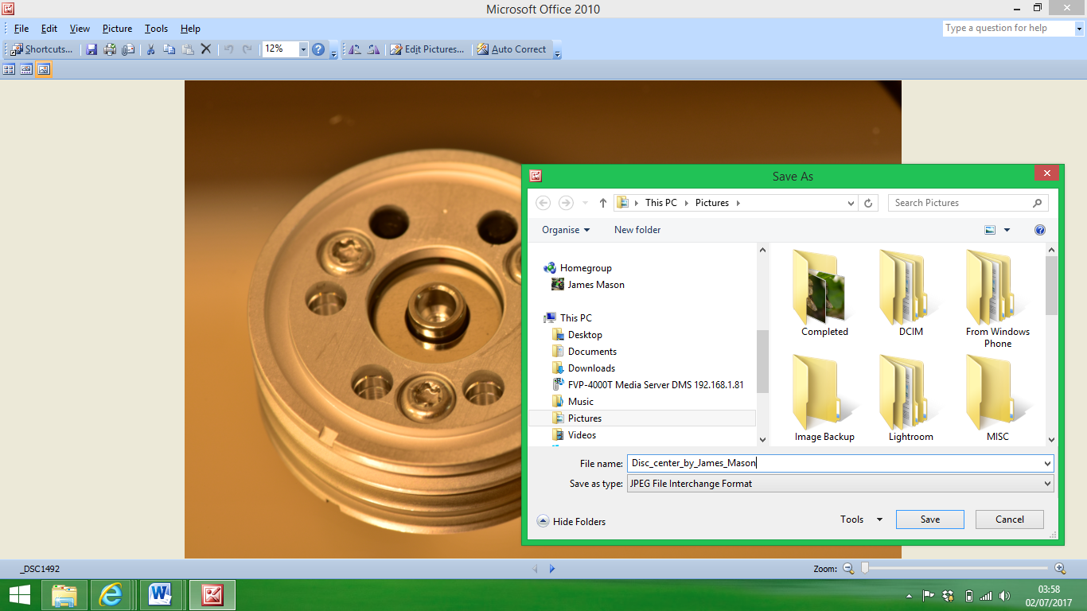
Once you have the pictures you want to upload onto the web page saved on your computer go to the website and Competitions page. At the bottom of the competition page under the online competitions details you will find the upload button.

Once this link is clicked, it will open up the browser for you to search for the file/picture that you saved previously.
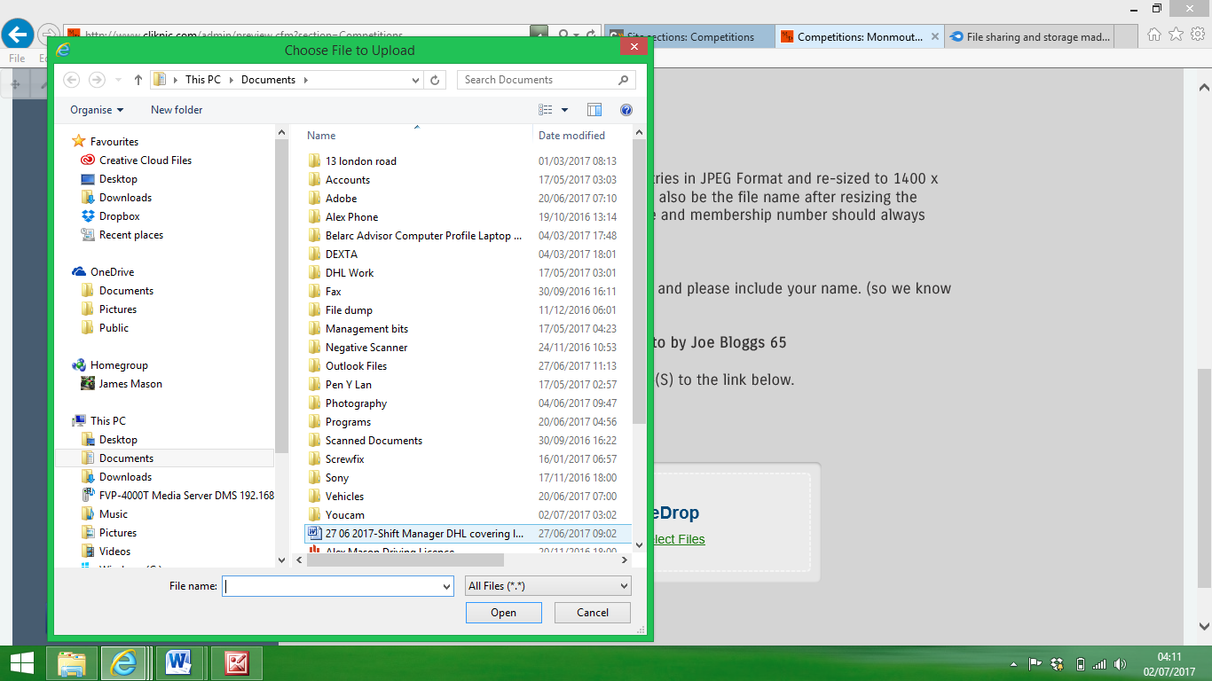
Search through for your picture, (I put mine in Pictures folder)
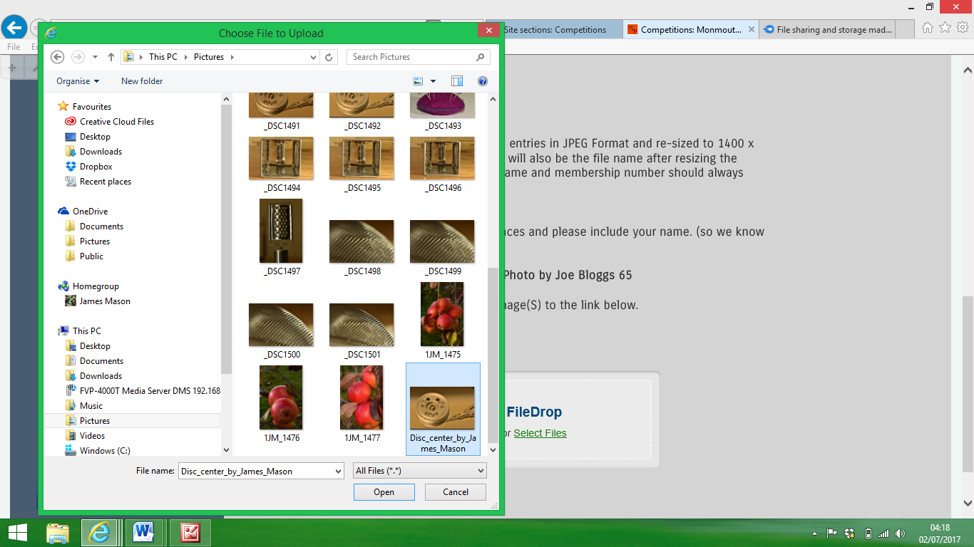

Click on picture and click open or double click on Picture.
The button will then change to let you know file selected and gives you the option to start uploading files or cancel.
Once upload has started you will get a progress bar.
Once upload complete it will let you know and ask if you wish to upload another? Click on link to upload another picture if required.

I hope this guide helps if you have any problems, please let us know by sending a message on the contact us page on the website.